 VINOD SIR’S GROUP TUTION

MARKS: 30 X-SCIENCE-I (1, 2 & 3) TIME: 1 Hr. 30 Mins.

Q. 2: Answer the following questions: (Any 3) [6]
1. Write the three laws given by Kepler. How did they help Newton to arrive at the inverse square law of gravity?
2. A stone thrown vertically upwards with initial velocity u reaches a height ‘h’ before coming down. Show that the time taken to go up is same as the time taken to come down.
3. Explain the term reactant and product giving examples.
4. Explain the similarity and difference in two events, namely adding NaOH to water and adding CaO to water.
5. Explain why the value of g is zero at the centre of the earth.

Q. 3: Give scientific reasons for the following: (Any 3) [6]

1. When the gas formed on heating limestone is passed through freshly prepared lime water, the lime water turns milky.
2. Elements belonging to the same group have the same valency.
3. The third period contains only eight elements even through the electron capacity of the third shell is 18 .
4. Metallic character goes on decreasing while going from left to right in a period.

Q. 4: Explain the following terms: [4]

1. Endothermic reaction 2. Combination reaction

Q. 5: Write the name and symbol of the element from the description. [2]
1. The atom having the smallest atomic mass.
2. The noble gas with the smallest atomic radius.

Q. 6: Write short notes for the following: [2]

1. Structure of the modern periodic table.

Q. 7: Observe the following picture a write down the chemical reaction with explanation: [3]

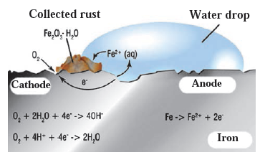

Q. 8: Identify from the following reactions the reactants that undergo oxidation and reduction.
1. 2Fe + O2 → 2FeO 2. CuO + H₂ → Cu + H₂O [2]
2 NiO + H2 → Ni + H2O

Q. 9: Balance the following equation stepwise. [2]
1. NaOH (aq) + H2SO4(aq) → Na2SO4(aq) + H2O(l)
2. Ca + HCl → CaCl₂ + H₂

Q. 10. Identify the endothermic and exothermic reaction. [2]
1. 2KClO3(s) 2KCl(s) + 3O2
2. NH₄NO₃ → N₂O + 2H₂O (absorbs heat)

